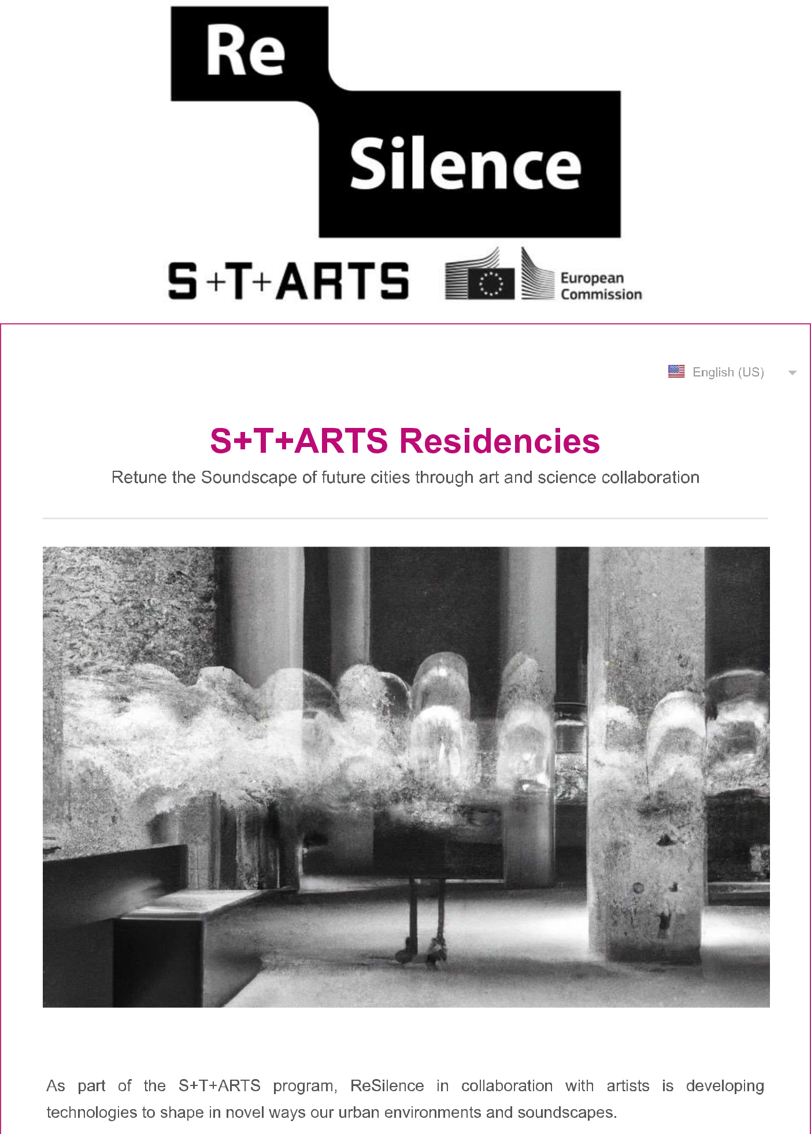

Part A - Type of Application / Summary of Proposed Work

QA1. Type of application. Are you submitting: *

a) As an individual artist

b) Αrtist - SME

QA2. Describe the main theme of your planned work and its focus in relation with the expertise of one or more project partners. (max 500 words)

QA3. Please describe your dissemination strategy and/or propose an exhibition venue (max 350 words) *

Part B - Previous experience

QB1. Describe your qualification for this call (max 350 words) *

QB2. Web links with images and/or videos showcasing recent work *

QB3. Please upload your CV (PDF format only) - (The uploaded file should not exceed 2-3 pages and an overall size of 8 MB)*

Choose File No file chosen

Upload your CV (max 8 MB)

Part C - Motivation, Ambition & Relation to ReSilence

QC1. What is your motivation for joining the ReSilence research team? (max 200 words) *

QC2. What will be the outcomes of this residency and how the outcomes will contribute to the project aims and research? (max 350 words) *

QC3. Describe how this project fits to your practice and the issues of your previous work? (max 350 words)*

Part D - Duration & Budget

QD1. Please upload your proposed budget and targeted time schedule of residency (.xls or .xlsx, pdf or zip formats only) - (The overall size of the uploaded file should not exceed 2 MB.) *

Choose File No file chosen

Upload your CV (max 2 MB)

QD2. Explain the allocation of the available budget uploaded above? (max 350 words)*

